WHAT’S THE MATTER?
Once again, we start with some Year 11 work.

Here is the 3AB outline of this topic.

Macroscopic properties of matter
- Interpret observations, such as the colour changes of physical and chemical systems at equilibrium
- Use observable properties, such as the colour of ions, to help predict and explain the formation of products in chemical processes (see data sheet)
- Use the Kinetic Theory to explain the concept of absolute zero
Solutions
- Apply the solubility rules to predict if a precipitate will form when two dilute ionic solutions are mixed (see data sheet)
- Perform concentration calculations (mol L⁻¹, g L⁻¹ ppm, percentage composition)
- Calculate the concentration of ions in solution for strong electrolytes
- Perform the calculation of concentration and volume involved in the dilution of solutions and the addition of solutions
Chemical Reactions
Reactions, equations and stoichiometry
- Describe, write equations for and interpret observations for the following reaction types:
- Precipitation
- Solvation of ions in aqueous solution
- Physical and chemical equilibrium
- Write ionic equations appropriate to the chosen context using ions in appendix 1.
- Perform calculations involving
- Conversion between Celsius and Kelvin temperature scales
- Mass, molar mass, number of moles of solute, concentration and volume of solution and gas volume using PV=nRT
- Percentage purity of reactants or percentage yield in industrial processes
- A limiting reagent, including:
- Identification of limiting reagents
- Calculation of excess reagents
Applied Chemistry
- Write the chemical formulae for molecular compounds based on the number of atoms of each element present as inferred from the systematic names
Write the molecular formulae of commonly encountered molecules that have non-systematic names

This part of the course is largely revision, with some extensions of ideas you are already familiar with.

Here is a list of tasks in what I think is a logical sequence. The list includes some reading, Review Exercises, Problem Sets and experiments.

Work through the list spending most time on the tasks that challenge you the most.

The Kinetic Theory and Absolute Zero

STAWA Exp’t 1 page 28
Do not attempt this experiment. Instead, use this data to help you answer the questions.

This experiment demonstrates why we always use the Kelvin scale when associating temperature to the other physical dimensions of gases (P and V). The explanation of the results is based on collision theory.

Here is some data for this experiment. Complete the table, consider the information it provides and then answer the Process Questions from page 30.

Temperature ºC | Temperature K | Pressure kPa
-10 |  | 94
0 |  | 98
25 |  | 112
50 |  | 115
85 |  | 128

- Apply the solubility rules to predict if a precipitate will form when two dilute ionic solutions are mixed (see data sheet)

Chemistry for WA Chapter 5.1 and exercise 5.1
Chapter 5.2 and exercise 5.2
STAWA Investigation 1 page 41 - Identify the unknowns –
Different substances dissolve in water to different extents.
Apply the solubility rules to identify the unknown solutions in Sets 1 and 2

- Perform concentration calculations (mol L⁻¹, g L⁻¹ ppm, percentage composition)
- Calculate the concentration of ions in solution for strong electrolytes
- Perform the calculation of concentration and volume involved in the dilution of solutions and the addition of solutions.
- Calculate the concentration of ions in solution for strong electrolytes
- Perform the calculation of concentration and volume involved in the dilution of solutions and the addition of solutions

Chemistry for WA Chapter 4.2 and exercise 4.2

Chapter 4.4 and exercise 4.4
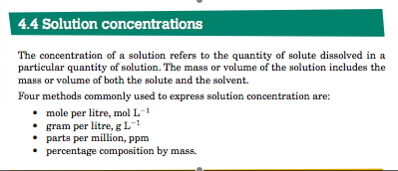

Chapter 4.5 and exercise 4.5

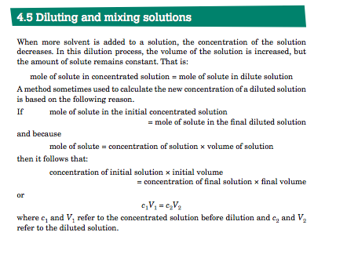
Questions page 118: 3, 4, 9, 10, 13, 14, 16, 18
Perform calculations involving
- Conversion between Celsius and Kelvin temperature scales
- Mass, molar mass, number of moles of solute, concentration and volume of solution and gas volume using PV=nRT
- Percentage purity of reactants or percentage yield in industrial processes
- A limiting reagent, including:
- Identification of limiting reagents
- Calculation of excess reagents

Chemistry for WA Chapter 5.3 and exercise 5.3
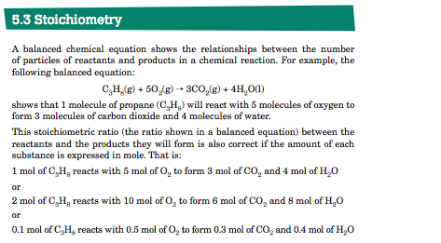
Chapter 5.4 and exercise 5.4
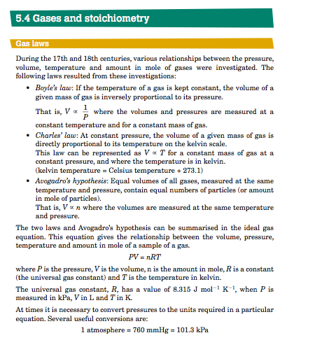
STAWA Problem Set 1 Gases p 47
Chapter 5.5 and exercise 5.5
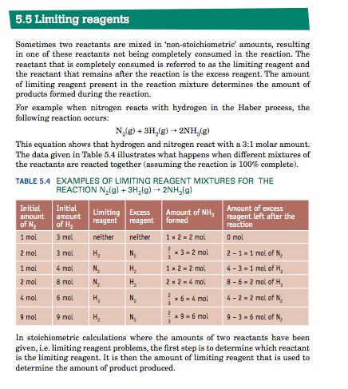
STAWA Problem Set 2 Limiting Reagents p 50

STAWA Investigation 3 page 46 – Determine the limiting reagent –
Gravimetric analysis (analysis using masses) can be used to determine the limiting reagent in many reactions.
The limiting reagent determines how much product is made. It is the chemical that gets used up.

Chapter 5.6 and exercise 5.6

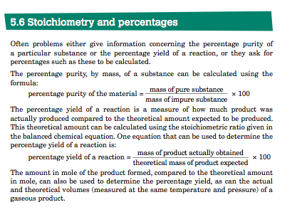
STAWA Problem Set 5 Percentage Composition and Yield p57
STAWA Investigation 2 page 45 – Determine the formula-
Determining the empirical formula of a compound is an important analysis technique. This investigation involves several steps. Make sure you know where you are going before you set off!

Questions page 148: 1, 2, 3, 4, 5, 6, 7, 11, 14, 16

